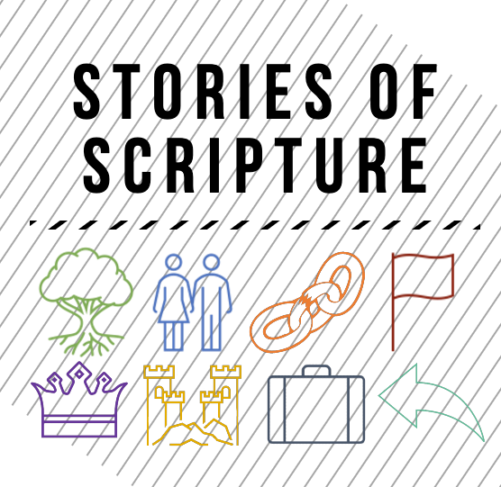

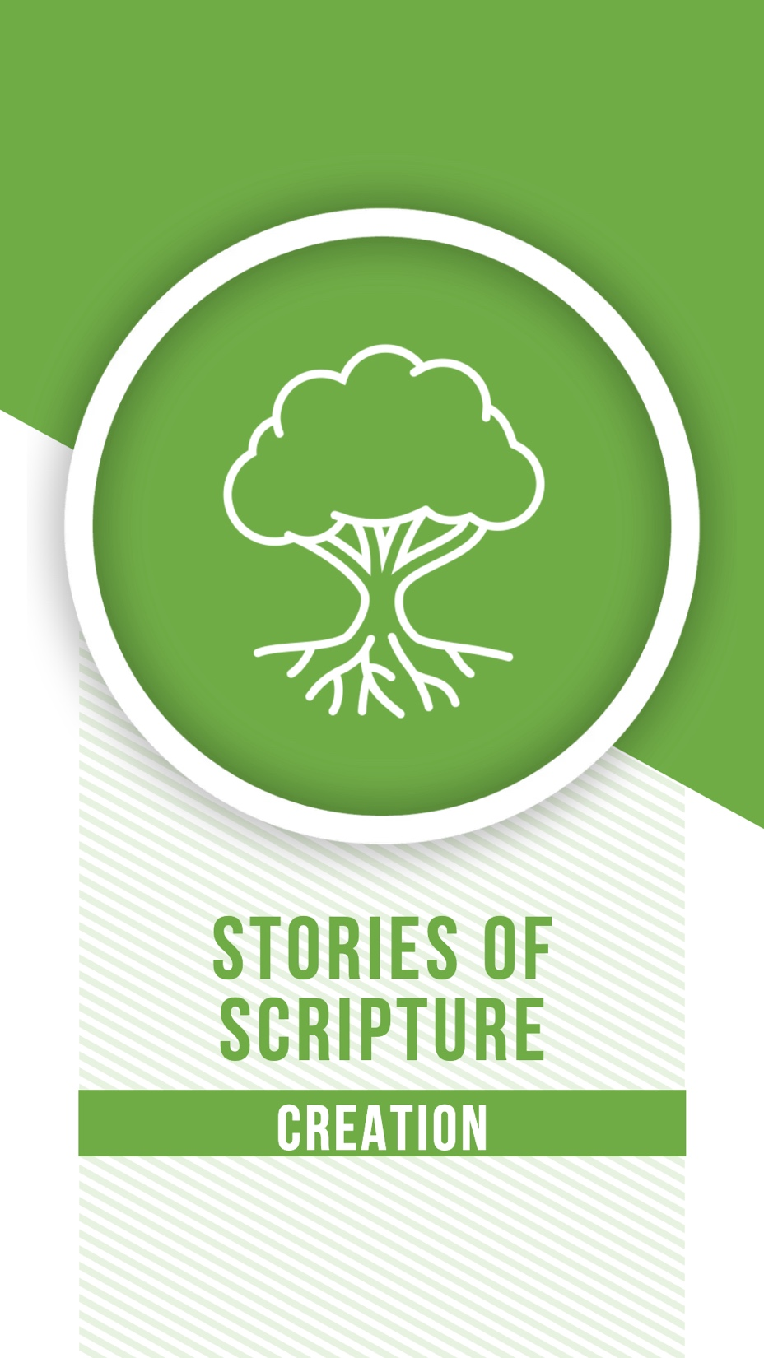Creation

In the beginning, God created the heavens and the earth. Genesis 1:1

The first few words of the Bible make a powerful statement about the nature of our God. To better understand the creation story in the Bible, it helps compare it to other creation stories found in ancient societies. Israel’s neighbors had their own stories of the world’s creation. They involve gods warring with one another and humans being created as an accident or to serve the gods like slaves. This story shaped the Babylonians’ ideas about the world. They feared their gods and felt the world was a scary place.

But the creation story we find in Scripture presents our God, the one true God, as powerful, intentional, and most of all personal. God created the heavens and the earth and everything in them. He did so with His breath, with His hands, with great care and passion. Our world, with all its complexities and intricacies, is not an accident. It was designed by the world’s greatest architect. It is sophisticated and beautiful.

In the course of this series, we will explore the overall narrative of Scripture. We will learn about the ups and downs of God’s relationship with humanity and God’s desire to live in relationship with creation. As we journey through the overall narrative of the Old Testament, it’s important to keep our origins in the back of our minds. God has a plan. God is deliberate. God is powerful. And God will stop at nothing to be united with His beloved creation; with you and with me.

Our world is not an afterthought or an accident. And through the ups and downs of history, God has always been at work. Open your eyes to see God creating in your life today.

Creation

So, God created mankind in his own image, in the image of God, he created them; male and female he created them. Genesis 1:27

What does it mean to be created in the image of God? Theologians have pondered this question for centuries, and they have come up with a few suggestions.

Humans are thought to be in the image of God because we have the capacity for deep and meaningful relationships. No other animal is able to build complex communities. The image might also mean that we have free will, and we are able to make moral decisions and be held accountable. Other animals operate on instinct or training, but humans can make real choices. We can choose to cheat our sibling or tell the truth to a friend. The image of God might also have to do with our role as stewards of creation. A “steward” is someone who rules when a king is away. Humans are supposed to rule over creation with compassion and justice. We are responsible for domesticating animals, farming the land, and building cities.

One interesting thing to note is that in the ancient Near East, the image of a god was thought to be an idol. The image was a physical statue that represented the god or goddess. It was something that was worshipped, and it might sit in a shrine or in a temple. To say that humans are the image of God is to say that we are special representatives of God here on earth. This means when we sin against one another, when we hurt one another, we are actually hurting God. Likewise, when we care for one another, we are caring for God.

I think this last idea is the most exciting and the most terrifying. The way we treat others is literally how we treat God. To put it the way Jesus did, if you want to love God with all your heart, then you must love your neighbor as yourself. Take time today to treat someone as God’s image here on earth.

Creation

They heard the sound of the Lord God walking in the garden at the time of the evening breeze, and the man and his wife hid from the presence of the Lord God among the trees of the garden. Genesis 3:8

If you’re not familiar with the end of the creation story, then I will summarize it for you briefly. God created the whole world and the first humans, named Adam and Eve. God put Adam and Eve in a beautiful garden and gave them everything they could ever want but told them not to eat from one particular tree. Of course, just like an unruly toddler tempted by a cookie jar, the man and the woman ate from the tree.

An interesting part of this story is the moment they sin against God, they felt ashamed. They felt regret. They knew they had messed up, and they didn’t want to face the consequences. Or perhaps, they didn’t want to face God knowing how disappointed He would be with them. Today’s verse says they hid from the presence of God. The idea of God’s presence comes up again and again in the Bible. People waver back and forth from wanting to be in God’s presence to being terrified of God’s presence. Maybe you recall a story Jesus told about a young man who was too ashamed of what he had done to come back to his Father’s presence.

The story of Scripture is about humanity’s journey back into the presence of God. Can you remember a time when you were wholly aware of God’s presence? Maybe it was in the middle of the wilderness or in the midst of worship? God’s presence is powerful and transformative, and God offers it freely to those who have faith in Jesus Christ. Be mindful of God’s presence today and take advantage of the abundant life offered by the Holy Spirit.

Creation

And when they were in the field, Cain rose up against his brother Abel and killed him. Then the Lord said to Cain, “Where is Abel your brother?” He said, “I do not know; am I my brother's keeper? Genesis 4:8-9

The story of Cain and Abel is sometimes called history’s first murder mystery. It’s terrible to think that we’re only four chapters into the Bible and humans are already killing one another. And these two guys are not even strangers. It’s not like Abel was threatening Cain or they were in some kind of struggle. This was violent, premeditated, first-degree murder.

However, matters of life and death are not always so straightforward. Many hot-button issues in our churches circle around life and death: capital punishment, war, abortion. Christians are all over the map on what ‘supporting life’ means with regard to these issues. The story of Cain and Abel introduces us to the challenges of death and life, grace and judgment.

And just why did Cain decide to kill Abel in the first place? Well, God liked Abel’s sacrifice better than Cain’s sacrifice, and Cain thought that was unfair. The truth is a lot of things in life are unfair. Other people may have more power, prestige, or popularity than you. They may have more money, better clothes, more athletic ability. These “better” people might even be in your own family. The truth is that life is unfair, and the temptation to give into jealousy can be overwhelming.

We are the spiritual children of Adam and Eve, who disobeyed God out of pride. We are also the spiritual children of Cain, bent on causing destruction out of selfishness. We may think of ourselves as above the sins of Cain because we have never resorted to violence. However, Jesus calls His disciples to a higher morality. Anyone who hates a brother or sister has already murdered them in their heart.

There is a hint of life in this story of death. After God confronts Cain about the murder, he did not put Cain to death. There was no capital punishment for the first murderer. Cain was allowed to live in exile. There is so much violence in this world, both in our hearts and in the streets. How can you be an advocate for life in the face of death?

Creation

I establish my covenant with you: Never again will all life be destroyed by the waters of a flood; never again will there be a flood to destroy the earth. Genesis 9:11

Churches have a strange habit of decorating their children’s spaces with images of Noah’s Ark. Sure, the animals are cute, and the boat is a fun idea. But if we take a look to examine this story closer, we would realize that the story of Noah’s Ark is a better theme for a haunted house or scary movie. In the story, God saw that nearly every human in the world was doing evil. So, God decided to start over. God called on Noah to build a boat and gather animals so that He could flood all of creation and begin anew with Noah’s family. Noah’s Ark is more like an apocalyptic action thriller than a feel-good story about animals, and the 2014 movie entitled Noah, gets its atmosphere about right, even if the story is a bit off.

Today, I want us to focus on the word “covenant.” A covenant is a special type of promise between two people or groups of people. It’s sort of like a holy contract, and there are penalties for violating the covenant. In Genesis 9, God issues his first of several covenants. In the story, this covenant is sealed with a rainbow.

If you think about it, there are very few covenants that you will enter into in your lifetime. One might be marriage. Another might be going into ministry. But the most important covenant that you will enter into is through the profession of faith you make in Jesus Christ. God established several different kinds of covenants with the people of Israel, and we will see through the story of Scripture that they broke every single covenant. In the same way, we will likely break our covenant with Jesus Christ at some point. But God never will. God will never break the covenant with us, even when we break our covenant with God. Have you entered into a covenant with God, and if so, what is the state of that covenant today?
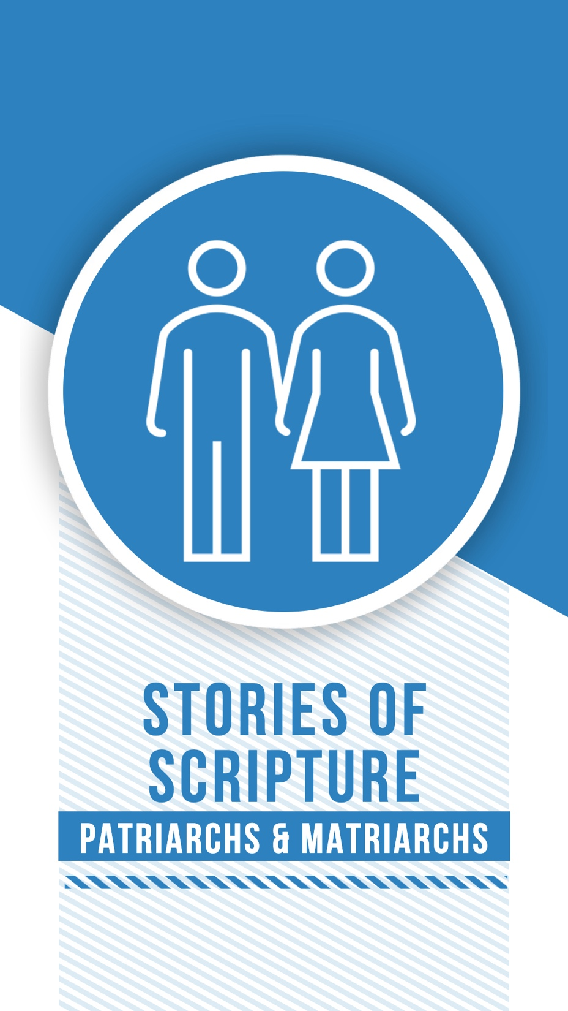

Patriarchs & Matriarchs

The Lord had said to (Abraham), “Go from your country, your people, and your father’s household to the land I will show you. I will make you into a great nation, and I will bless you; I will make your name great, and you will be a blessing.” Genesis 12:1-2

Yesterday, we talked about God’s first covenant with humans after the flood story. In today’s verse, we are dealing with God’s second covenant, which is specifically between God and Abraham and Sarah. In exchange for faithfully serving God, the couple is promised children. And there will be so many children that their family will become a great nation. God promised them land on which to build their nation and that they will be a blessing to the whole world because of their faith.

However, before any of this can happen, Abraham and Sarah must leave home. They must leave the comforts of familiarity and protection of their current community. They must literally walk with faith into the unknown.

It is difficult to be a blessing to others when we stay inside our comfort zones. And there are plenty of opportunities in our lives to walk in faith into the unknown. Perhaps the most frightening transition in a young person’s life is changing schools. Maybe that student has moved or is going off to college. In I960, Ruby Bridges was just six years old when she agreed to be the first Black student to attend an all-white elementary school in Louisiana. She walked to school every day, escorted by law enforcement while being threatened by an angry racist mob threatening to kill her. Officers later recalled, “She showed a lot of courage. She never cried. She didn’t whimper. She just marched along like a little soldier, and we’re all very, very proud of her.”

The Bible says Abraham and Sarah were 75-years-old when they followed God’s call into the unknown. Ruby Bridges was only six. How is God calling you into the unknown? And how can your faith be a blessing to others?

Patriarchs & Matriarchs

“Do not lay a hand on the boy,” God said Abraham. “Do not do anything to him. Now I know that you fear God, because you have not withheld from me your son Isaac, your only son.” Genesis 22:12

Abraham and his wife Sarah were incredibly old when God promised to give them children. God vowed to make their family into a great nation. Sarah found the idea so crazy that she laughed behind the back of God’s messengers who told them they would have children. When she finally became pregnant and gave birth, they named the child Isaac which means “he laughs,” and this time, her laughter was of pure joy.

However, God commanded Abraham to take this son Isaac to the top of a nearby mountain and sacrifice him as a burnt offering. Abraham bound his son with rope and set him on an altar, and when he raised the knife over the boy to kill him, the Lord suddenly stopped Abraham, and provided a ram to sacrifice instead. Abraham showed he was willing to give up the most precious thing in the world to him so he could be faithful to God. He passed the agonizing test, and God knew he would be the one through whom all humanity would be blessed.

Even if we, the reader, know from the start that this is only a test, it’s a pretty terrible test to put someone through. Academic scholars will say that this story actually functions as an important lesson for ancient Israelites to understand child sacrifice is completely off-limits. It was something that their neighboring peoples practiced. But what kind of God would even test someone in such way? Christian writers have filled entire sections of libraries exploring this one passage from Scripture. There are details in the story on which we should reflect with great care. Isaac obeyed his father and carried the wood himself to the top of the hill. Abraham freely offered his one and only son, though he loved Isaac more than anything. Though a son was not sacrificed that day, a Son was sacrificed hundreds of years later on a different hill called Calvary. From this moment forward, Abraham is considered the Father of the faith, and this episode foreshadows the foundational story of the Christian faith: the life, death, and resurrection of Jesus Christ, who is Himself a descendant of Abraham and Isaac and the children that follow. The Son of God has not been withheld as a sacrifice for our salvation, therefore let us pursue the cause of heaven with renewed passion and thanksgiving.

Patriarchs & Matriarchs

“I am the Lord, the God of your father Abraham and the God of Isaac. I will give you and your descendants the land on which you are lying… I am with you and will watch over you wherever you go, and I will bring you back to this land. I will not leave you until I have done what I have promised you.” Genesis 28:13-14

In today’s passage, God renews his covenant with a man named Jacob, who is Abraham's grandson. In the story, Jacob is wandering in the desert, having run away from home after cheating his brother out of his inheritance. Jacob is not a hero. He is dishonest, crafty, and selfish. His rebellious choices have forced him to flee from his home and his family. He is not unlike the Prodigal Son who has left home for wilder living. But as he sleeps under the stars, God appears to him for the first time in a dream.

God explains the covenant held with his father Isaac and his grandfather Abraham. It’s unclear if Jacob has heard of the promises before now. He certainly hasn’t been worshiping or seeking after God. But God wants Jacob to know that there are blessings in store for him regardless of his past actions and, what’s even more amazing, Jacob’s future commitment. God is going to bless Jacob. God is going to show Jacob kindness, love, and grace even though he has done nothing to earn it.

In this part of the story, only Jacob’s parents and grandparents have faith in God. Jacob, young and strong-willed, has never expressed any real faith of his own. But he decided that if God keeps his promise and brings him back home one day, THEN he will be faithful to God.

Jacob spent most of his life wrestling with the God of his parents and grandparents. Faith never came easy for him. He was always trying to resist the temptation around him. Later in Genesis, God gave him the new name, Israel, which means “wrestles with God,” describing Jacob’s faith journey. The name Israel comes to represent all of his descendants.

What about you? Do you feel like your faith comes easy like Abraham and Isaac? Or do you wrestle with God as Jacob does? Take time today to reflect on God’s graciousness in the midst of our rebelliousness.

Patriarchs & Matriarchs

“I am your brother Joseph, the one you sold into Egypt! And now, do not be distressed and do not be angry with yourselves for selling me here, because it was to save lives that God sent me ahead of you.” Genesis 45:4-5

The story of Joseph is not just a rags to riches story. It’s more of a riches to rags to riches story. Joseph was one of the youngest sons of Jacob, grandson to Isaac, and great-grandson to Abraham. He started out life as the favorite child and his father gave him a beautiful coat to distinguish them from his brothers. Now, I’m sure that your parents never played favorites, but as you can imagine, this didn’t go over very well.

Fueled by jealousy, his brothers kidnapped him and sold him into slavery. He worked his way up as a slave but was eventually wound up in prison through no fault of his own. After years of ups and downs, Joseph made his way to the court of pharaoh in Egypt. He became second in command over the biggest empire in the world at the time. Eventually, he reunited with his brothers when they came to beg for food from the Egyptians.

Sibling rivalry is a powerful force. In Genesis, we have seen brothers scheme against one another, even kill each other out of envy. Joseph’s brothers intended to hurt him. They wanted to punish him. But God took their evil actions and was able to use something terrible for a good purpose. Joseph ends up forgiving his brothers saying, “ You intended to harm me, but God intended it for good...”

Our God is powerful and creative enough to take even our most terrible sins and use them for his purpose. This is one of the biggest themes of the Christian story. In fact, that is exactly the story of the cross. The Romans and Jewish authorities intended for the cross to destroy the Jesus movement. They wanted Jesus dead and His followers scattered. But God used the evil of the cross to bring about salvation for the entire world. What some intended for harm, God used for good. How might God be turning your difficult situation into something good?

Patriarchs & Matriarchs

Then a new king, to whom Joseph meant nothing, came to power in Egypt. “Look,” he said to his people, “the Israelites have become far too numerous for us. Come, we must deal shrewdly with them” … So, they put slave masters over them to oppress them with forced labor. Exodus 1:8-11

In today’s passage, we have moved into the third phase in our biblical timeline: The Exodus. Many generations had passed since Joseph was in charge of Egypt. Joseph and his brothers have had children, and those children have had children. They are no longer just a big extended family; the Israelites are a whole ethnic group.

The new Pharaoh in Egypt had become nervous about these Israelites. The Egyptians did not want to share power with these immigrants. They were viewed as a threat even though they had done nothing to deserve it. So, a plan was developed. The Israelites would be oppressed through slavery. The process began with forced labor but grew to include other acts of violence, terror, and even ethnic cleansing. This was the first documentation of Jewish oppression, but far from the last time that they would suffer. They would face persecution from nearly every nation right up until to today.

Unfortunately, human history is filled with horrors of slavery and genocide. These moments seem to follow a very specific formula. There are two groups of people, and the leaders of one group spread fear about the other group, that they are dangerous or corrupt and need to be controlled. If we don’t get them under control now, then they will be our downfall. And slavery is not just a relic of the past. It’s thought that more than 40 million people live in slavery today.

What we learn from the Exodus is that God is on the side of the oppressed, not the side of the oppressor. God is not just concerned with our spiritual salvation but our bodily liberation. Christianity is not just about believing the right things. In Luke 4, Jesus used His first sermon to proclaim freedom for the prisoners to set the oppressed free. Today, take time to examine the news. Where do you hear voices of fear and oppression, and where do you hear voices of liberation? Which voice will you listen to?

